Chapter 19, Problem 64.

Determine the y parameters at ω = 1,000 rads for the op amp circuit in Fig.19.111. Find the corresponding h parameters.

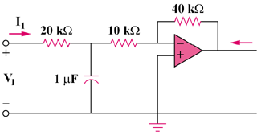

Figure 19.111
For Prob. 19.64.

